Project Design Phase Solution Architecture

Date | 05/07/26
Team ID | SWTID-2026-9649
Project Name | Sports Hall Booking System by Service Portal(ServiceNow)
Maximum Marks | 4 Marks

Solution Architecture Overview

The Sports Hall Booking System is developed using the ServiceNow platform to provide a centralized solution for managing sports hall reservations. The system allows users to view sports hall information, submit booking requests, and track their bookings, while administrators can manage sports halls and booking records. ServiceNow automation features help reduce manual work and improve the efficiency of the booking process.
Architecture Components

Component | Description
Users | View sports halls, submit booking requests, and track bookings.
Administrators | Manage sports hall information and booking records.
User Interface | Provides access to the Sports Hall Booking System.
Sports Hall Booking Application | Handles hall and booking management.
Business Rules | Performs booking validation and business logic.
Flow Designer | Automates booking-related processes.
Scheduled Jobs | Executes scheduled and automated tasks.
Data Tables | Stores sports hall and booking information.
Notifications | Provides booking confirmations and status updates.
Reports & Dashboards | Displays booking information and analysis.

Architecture Flow

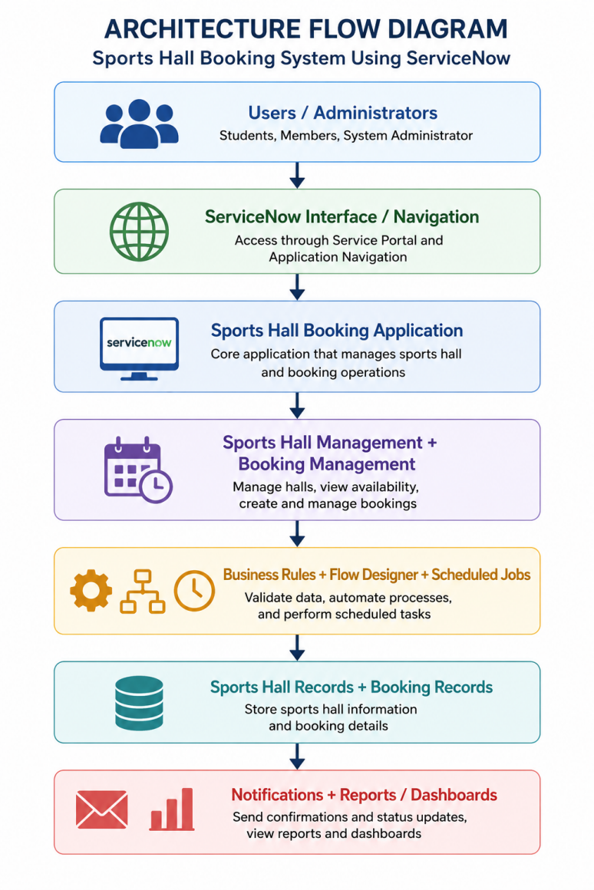
Architecture Diagram

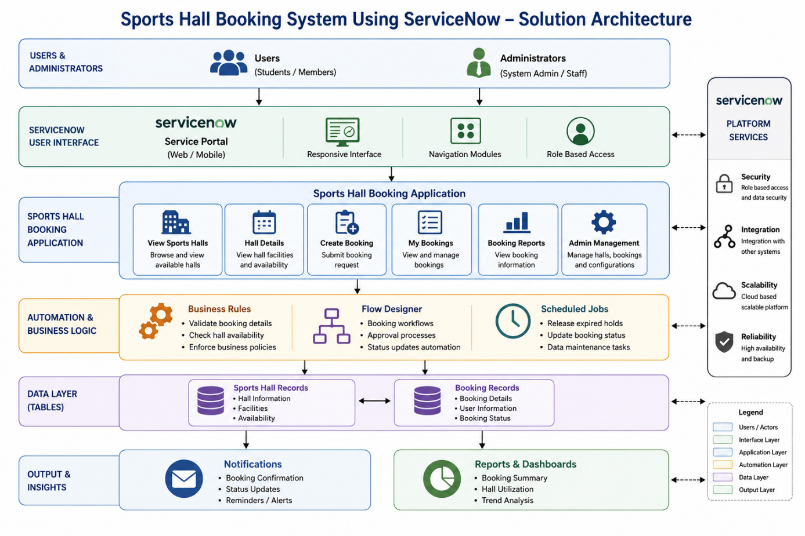

Conclusion

The solution architecture integrates the user interface, booking management, automation, data storage, notifications, and reporting capabilities within the ServiceNow platform. This provides an organized and efficient solution for managing sports hall reservations.

